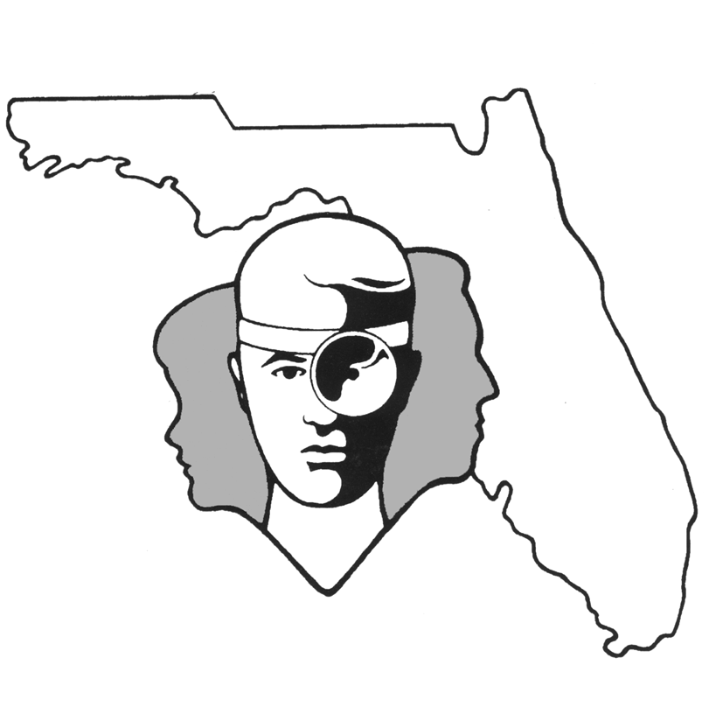
TALLAHASSEE EAR, NOSE & THROAT - HEAD & NECK SURGERY, P.A.

www.TallyENT.com Office Phone: 850-877-0101

PATIENT DISCHARGE INSTRUCTIONS: SEPTOPLASTY with or without TURBINATE REDUCTIONS

POST-ANESTHETIC CONSIDERATIONS: Anesthetics and other medications will be in your body 24 hours, so you may feel a little sleepy. This feeling will slowly wear off, but for the next 24 hours, adults should not:
- Drive a car, operate machinery or power tools ● Drink any alcoholic beverages
- Take any medication except as directed ● Make any important decisions – such as signing legal documents
Certain anesthetics and pain medications may produce nausea & vomiting which usually resolves by the evening of the surgery.

ACTIVITY: In general, you should avoid any kind of heavy exercise or straining for two weeks. After this time, gradually increase exercise.
DIET: You should progress slowly to a regular diet as tolerated. It is better to start with liquids such as Ginger Ale or apple juice, then soup and crackers, and gradually solid foods.

WOUND CARE: You may take a shower or bath as desired. You may change nasal tip dressing as needed and as demonstrated. If there is no drainage, you may remove the dressing. Unless otherwise instructed, begin saline nasal spray (available over the counter as Nasal, Ocean, or Ayr) after surgery. You can also use antibiotic ointment on a Q-tip. Use three to four sprays every two to three hours while awake. You may experience bloody nasal secretions until the internal splints are removed in approximately one week. Do not blow your nose! If you feel like you are going to sneeze, please try to do it with your mouth open. Also, it is best if you can keep your head elevated. Do your best to keep the cast dry, if you have a cast.
MEDICATIONS: You should have a medication for pain and possibly an antibiotic. If given an antibiotic, be sure to take the antibiotic as prescribed and for the full time recommended by your surgeon. If you do not have these, please ask your surgeon about them to make certain. Unless otherwise indicated, you may try taking an antihistamine/decongestant, which might help a little with nasal congestion. For bleeding, you may try using a topical nasal decongestant (such as Afrin or Duration). Use only Tylenol or other pain medication prescribed by your surgeon. Do not take aspirin or anti-inflammatory products (Motrin, Ibuprofen, Advil, Aleve, etc.), or any other pain medication other than that prescribed by your surgeon. This is very important as some of these medications can cause bleeding.
SYMPTOMS TO EXPECT: You can expect moderate discomfort the first night. Most patients feel better the second and third days, then slightly worse the fourth day on, until the splints are removed. You may have some bruising around the eyes and a bruised or swollen upper lip. You can expect red (bloody) fluid-type drainage from your nose with some postnasal drainage with this as well. In general, it should gradually decrease over the first couple of days. Your nasal tip may be very tender. Also, you may have absorbable stitches just inside your nose. In regard to the turbinate reductions, there may be bleeding in the immediate postoperative period.

WHEN TO CALL YOUR PHYSICIAN:
- If you have brisk bleeding (a fast drip-drip), have purulent (pus-like) drainage, expel clots, and/or
begin to swallow blood
- If you have a temperature of more than 101.5 degrees at any point
- Pain or nausea uncontrolled by the prescribed medications

SPECIAL INSTRUCTIONS: A postoperative appointment has already been scheduled. Please refer to your Surgery Information Sheet or call the office to confirm the appointment date and time. We strongly suggest that a responsible adult be with the surgical patient the rest of the day and also during the night for the surgical patient's protection and safety. Please contact your physician immediately if you have an emergent situation. If you find that you cannot contact them, but feel that your signs and symptoms warrant a physician's attention, go to the nearest emergency room. For non-emergent questions (i.e. appointments or general questions), please call during normal office hours.

